

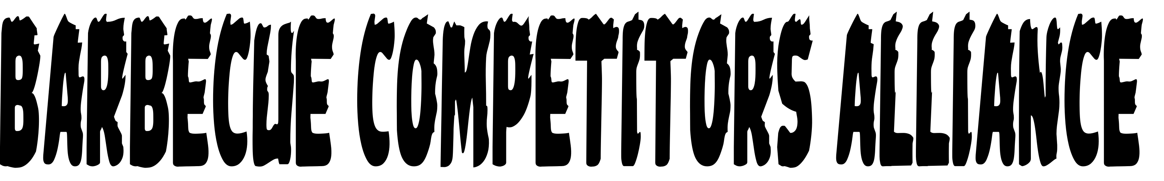
Sponsorship Opportunities

Mission Statement
The Barbecue Competitors Alliance (BCA) is a 501(c)(4) nonprofit corporation dedicated to assisting the general public in promoting, cooking, enjoying, and teaching barbecue and related meat smoking techniques.

Provided Services
1. BCA is dedicated to be the sanctioning body of choice for low-cost (less than $175) "cook friendly" barbecue contests.
2. BCA provides assistance to a variety of civic and other charitable organizations in helping to organize, promote, and produce sanctioned barbecue contests.
3. BCA through its members teaches barbecue and related cooking techniques to the public.
4. BCA coordinates time and resources to cook barbecue and related food items to any person affected by natural disasters.

Information About BCA
1. Created by cooks for cooks in October 2014.
2. Participants prepare a minimum of half chicken, pork spare ribs, and beef brisket for BCA sanctioned contests. Pulled pork can also be a meat category that counts for grand champion at BCA contests.
3. Rules are similar to those in other "double blind" contest formats with the addition of a computer-based scoring system, breaking ties in the top ten using judges, implementing half scores in the final round, allowing judges to use comment cards to give cooks feedback on their entries, and making scores available to cooks after the contest.
4. BCA sanctions about 15-20 contests with payouts of between 1,000 and $15,000. Each contest has an average of more than thirty cooks.
5. BCA has a "Points Chase" each year with cash prizes. The winner of this chase gets the "Pelican Cup" and is the best cook for the given year.
6. BCA also has a Best New Head Cook award with a cash prize.
7. BCA sponsors at least one cooking class for competition cooks and the general public each year.
8. BCA is developing a yearly Invitational Contest for members.

Sponsorship Opportunities
1. Yearly Points Chase Awards - Any amount is appreciated.
2. Yearly Best New Head Cook Award - Any amount is appreciated.
3. Invitational Contest - Few hundred dollars (prizes for one category) to thousands of dollars (prizes for whole contest).
4. Cooking Classes - Any amount is appreciated.
5. Large naming right sponsorships are available.
6. Material Sponsors - Provides materials for disaster relief (any amount).
(Sponsors will get name, logo, and literature displayed with the award/event)

Contact Information
Contact BCA Past President Andy Hollerman at pastpresident@bcabbq.org or (337) 278-4632 for additional sponsorship information. The mailing address for BCA is at 46406 North Morrison Blvd., Suite A, Hammond, LA 70401.

http://www.bcabbq.org

